A000-Asia-Japan-Haniwa-Female Scribal Figure-Kofun Period-250 to 538 CE

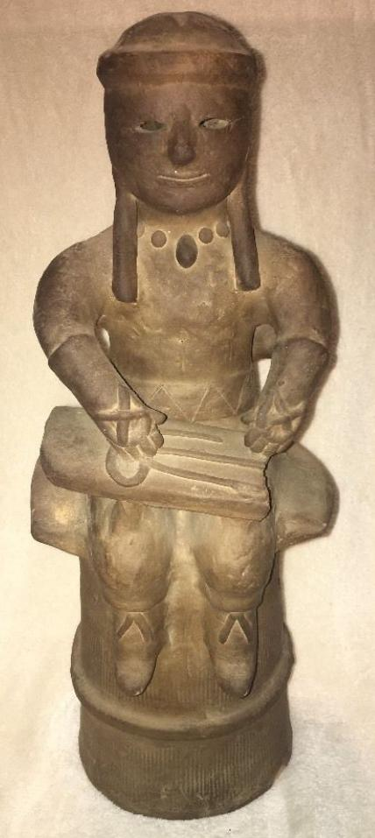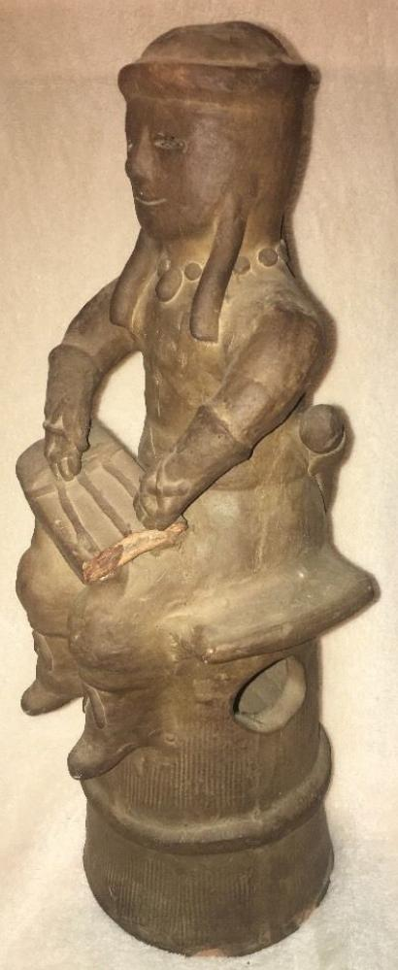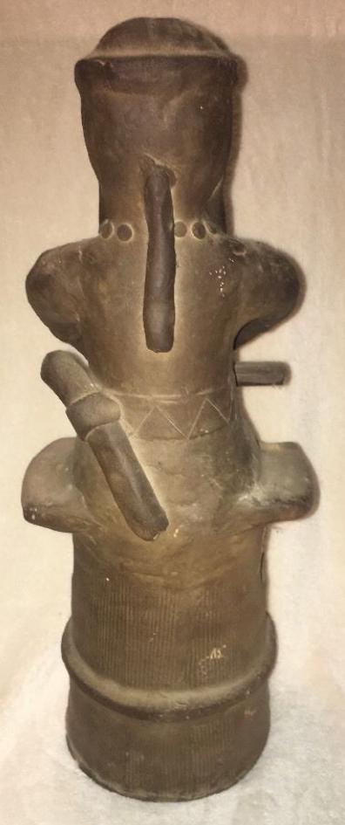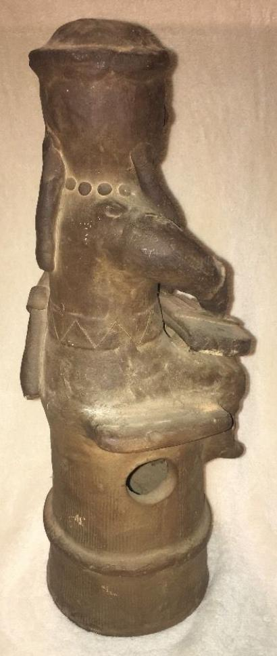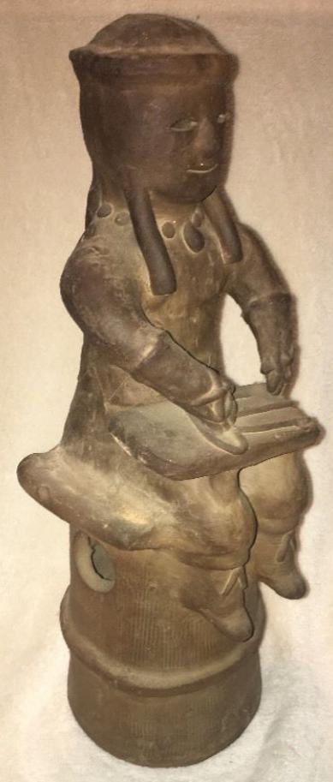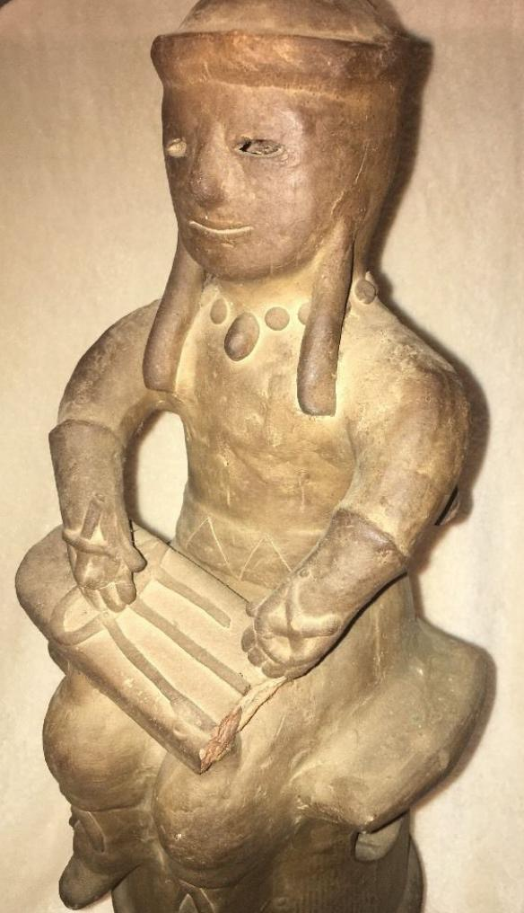

Formal Label: Asia-Japan-Haniwa-Scribal Figure-Kofun Period-250 to 538 CE

Case No.:

Accession Number: NB 1667.A3

Display Description: Haniwa means “clay cylinder.” These are unglazed ceramics that were made during the Kofun period of Japan. Initially in the Early Kofun Period they were used as offerings to royalty and the gods from the third to the sixth century. Then a change at the end of the Middle Kofun period from the construction of royal graves as loci for the consumption of traditional prestige goods unconnected with economic production, to a society in which prestige goods were produced and distributed for the purpose of tomb construction for non-royalty (Kawano 2008). This observation would seem to place this ceramic within this class.

Date or Time Horizon: 250 to 538 CE

Geographical Area: Japan

Cultural Affiliation: Middle Kofun Period

Medium: Terracotta

Dimensions: H 16.5 in

Weight:

Provenance: U.S. Naval Captain, Occupied Japan, 1947.

**Condition:** Missing piece on scribal plaque.

Discussion:

References:

Kawano Kazutaka 河野一隆, “Kokka keisei no monyumento to shite no kofun” 国家形成のモニュメントとしての古墳 (Kofun Tumuli as Monuments of the State Formation Process), Shirin 史林 (The Journal of

History) 91, no.1: 33-66.